**Year 7 – Humanities and Social Sciences**

**Task 1 – Designing and Creating a Fact Sheet (5%)**

**Topic: Water Scarcity**

**(Part A: Inquiry Booklet) Mark:­­__________/76**

**Curriculum:** Water [scarcity](http://k10outline.scsa.wa.edu.au/home/p-10-curriculum/curriculum-browser/humanities-and-social-sciences/humanities-overview/glossary/scarcity) and what causes it, why it is a problem and ways of overcoming water [scarcity](http://k10outline.scsa.wa.edu.au/home/p-10-curriculum/curriculum-browser/humanities-and-social-sciences/humanities-overview/glossary/scarcity) e.g. **reducing water consumption,** including studies drawn from Australia.

**Your Task:**

Create a fact sheet which educates people about water scarcity. The fact sheet must provide an overview of the issue of water scaricty and then focus on the causes and impacts of water scarcity in **Australia** and a **chosen** country in North Africa. The fact sheet must include the strategies that are used to manage water scarcity and a proposal for further action that is required to manage the issue in both countries.

* You must choose one of the following countries in Northern Africa;
  + **Algeria**
  + **Libya**
  + **Egypt**
  + **Sudan**
  + **Ethiopia**
  + **Mali**
* **You will need to design a fact sheet which addresses the following key areas;**
* Define the issue of water scarcity.
* The causes and impacts of water scarcity in Australia.
* The causes and impacts of water scarcity of **a** country in Northern Africa.
* Management strategies that are being used in Australia and your chosen country in Northern Africa.

The information must be supported by the use of statistics and at least one form of graph.

* **You must also include…**
* [](https://www.bing.com/images/search?view=detailV2&ccid=Z7CUbnwR&id=09BA5E97D3A8FBE09B1E7CE4AA529FF329481AB6&thid=OIP.Z7CUbnwRWulIgQjgryaqTQHaHa&q=Water+Scarcity+Art&simid=608024103991052775&selectedIndex=1)*Bibliography (Completing the recording sheet does not count as a formal bibliography)*
* *Planning documents*

**Part A: Inquiry Booklet**

**Section 1: Planning the inquiry**

*Complete the spaces below in order to successfully plan your inquiry.*

1. Define “water scarcity” Be sure to use examples to support your definition.

**(2 marks)**

1. What exactly am I being asked to do? Highlight the key words from the task summary.

Teacher to tick when completed

Date:­­

Teacher Initial:

1. What do I already know about the topic? What do I need to know? (Learnt column to be completed at the end) **(8 marks)**

|  |  |  |
| --- | --- | --- |
| *What I* **K***now* | *Want to Learn* | *What I Learnt* |
|  | Teacher to tick when completed  Date:­­  Teacher Initial: |  |

**NOTE-TAKING SHEET**

**(10 marks)**

**Focus Question 1**

|  |
| --- |
|  |

**Extract keywords from information source**

|  |
| --- |
|  |

**Key facts/data:**

* **Statistic 1:**

* **Statistic 2:**

* **Statistic 3:**

Teacher to tick when completed

Date:­­

Teacher Initial:

**NOTE-TAKING SHEET**

**(10 marks)**

**Focus Question 2**

|  |
| --- |
|  |

**Extract keywords from information source**

|  |
| --- |
|  |

**Key facts/data:**

* **Statistic 1:**

* **Statistic 2:**

* **Statistic 3:**

Teacher to tick when completed

Date:­­

Teacher Initial:

**NOTE-TAKING SHEET**

**(10 marks)**

**Focus Question 3**

|  |
| --- |
|  |

**Extract keywords from information source**

|  |
| --- |
|  |

**Key facts/data:**

* **Statistic 1:**

* **Statistic 2:**

* **Statistic 3:**

Teacher to tick when completed

Date:­­

Teacher Initial:

**NOTE-TAKING SHEET**

**(10 marks)**

**Focus Question 4**

|  |
| --- |
|  |

**Extract keywords from information source**

|  |
| --- |
|  |

**Key facts/data:**

* **Statistic 1:**

* **Statistic 2:**

* **Statistic 3:**

Teacher to tick when completed

Date:­­

Teacher Initial:

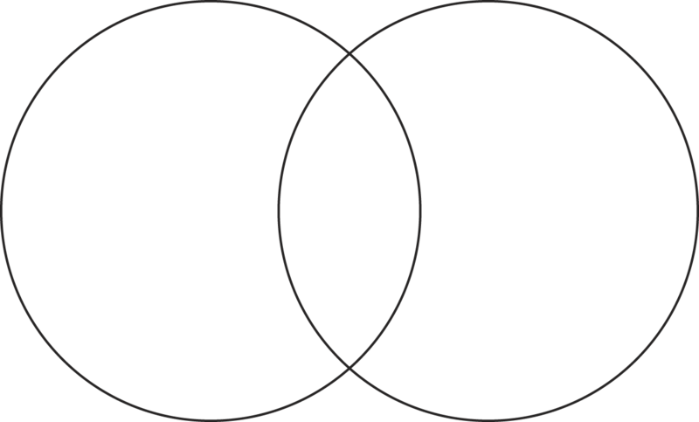**Venn diagram:** Comparing similarities and differences Water Scarcity in **Australia** to your chosen country in Northern Africa.  **(12 marks)**

___________________________________

_________________________________

Teacher to tick when completed

Date:­­

Teacher Initial:

___________________________________________________

Teacher to tick when completed

Date:­­

Teacher Initial:

**The ethical recording and communicating of evidence:** List the bibliography information of all resources from which you have taken information. You are legally required to acknowledge the author or editor who wrote or compiled the information you have used for your assignment.

**Bibliography/reference list framework**

|  |  |  |  |  |  |
| --- | --- | --- | --- | --- | --- |
| **Author** | **Date last updated** | **Title of Webpage** | **Date accessed** | **HTTP** | |
|  |  |  |  |  | |
|  |  |  |  |  | |
|  |  |  |  |  | |
|  |  |  |  |  | |
|  |  |  |  |  | |
| **Author** | **Date of Publication** | **Title of Book** | **Publisher** | | **Place of Publication** |
|  |  |  |  | |  |
|  |  |  |  | |  |
|  |  |  |  | |  |
| **Author** | **Date last updated** | **Title of Webpage** | **Date accessed** | **HTTP** | |
|  |  |  |  |  | |
|  |  |  |  |  | |
|  |  |  |  |  | |
|  |  |  |  |  | |
|  |  |  |  |  | |
|  |  |  |  |  | |
| **Author** | **Date of Publication** | **Title of Book** | **Publisher** | | **Place of Publication** |
|  |  |  |  | |  |
|  |  |  |  | |  |
|  |  |  |  | |  |

**Please note that completing the framework is a recording sheet not a formal bibliography**

1. **Complete the PMI chart below (THE TASK)**

**(6 marks)**

|  |  |  |
| --- | --- | --- |
| P – Plus | M - Minus | I - Interesting |
| Positives (Pluses) about the task | Negatives (Minuses) about the task | Interesting parts of the task |
| *  * | *  * | *  * |

**2.Complete the PMI chart below (THE TOPIC)**

|  |  |  |
| --- | --- | --- |
| P – Plus | M - Minus | I - Interesting |
| Positives (Pluses) about the topic | Negatives (Minuses) about the topic | Interesting parts of the topic |
| *  * | *  * | *  * |

Teacher to tick when completed

Date:­­

Teacher Initial:

Name:____________________________ My Target:_______/76 or _______%

**Year 7- Geography- Title of task: Designing and creating a fact sheet (Inquiry Task)**

**DETAILED MARKING GUIDE/RUBRIC**

**PART A: INQUIRY BOOKLET (2.5%)**

|  |  |  |  |  |  |  |
| --- | --- | --- | --- | --- | --- | --- |
|  |  | |  |  | **2 marks** | **1 mark** |
| **Definition**  **/2** |  | |  |  | Provides a detailed definition of water scarcity with the use of examples to support the definition. | Provides a brief definition of water scarcity and/or uses examples to support their definition.  No definition is supplied(0) |
|  |  | |  | **7-8** | **4-6** | **0-3** |
| **KWL**  **/8** |  | |  | Presents a very detailed and comprehensive plan through the use of a KWL chart. Comprehensive detail is used in each section of the KWL chart, which relates clearly to water scarcity in Australia and a chosen country in Northern Africa. | Presents a less detailed plan, through the use of a KWL chart. Less comprehensive reference to water scarcity in Australia and a chosen country in Northern Africa. | Presents a generalized plan and/or limited plan through the use of the KWL chart. Limited references are made to the chosen geomorphic hazard.  No KWL Chart is submitted (0) |
|  |  | |  | **7-8** | **4-6** | **0-3** |
| **Focus questions**  **/8** |  | |  | Devises a set of questions which clearly identifies the key information needed to address the research question. | Devises a set of questions which identifies some information needed to address the research question. | Lists a few simple questions which identify limited information. |
|  | **16-20** | | **11-15** | **6-10** | **1-5** | **0** |
| **Note taking**  **/20** | Provides very detailed, comprehensive and accurate notes. Notes address research areas in detail.  Uses evidence from a range of relevant sources. | | Provides detailed and mostly accurate notes which address the research areas.  Uses evidence from a range of sources which are mostly relevant. | Provides notes of adequate detail which attempt to address the research areas.  Uses evidence from a few sources which are somewhat relevant. | Notes are limited in detail and do not address the research detail.  Uses little evidence from limited sources which have little or no relevance. | Notes are not submitted. |
|  | **10-12** | | **7-9** | **4-6** | **1-3** | **0** |
| **Statistics**  **/12** | Uses a comprehensive list of data and statistics that address the research areas and support the formulated focus questions. | | Uses a list of data and statistics that address the research areas and somewhat support the formulated focus questions. | Uses few data or statistics. The data/statistics supplied somewhat address the research areas and focus questions. | Data/statistics supplied fail to address the research areas and focus questions. | No data or statistics have been supplied. |
|  |  | | **10-12** | **7-9** | **4-6** | **0-3** |
| **Venn Diagram**    **/12** |  | | Provides a very detailed comprehensive and accurate Venn diagram comparing water scarcity in Australia and their selected country. Clearly label all sections of the Venn diagram. | Provides a less detailed and mostly accurate Venn diagram comparing water scarcity in Australia and their selected country. Clearly labels all sections of the Venn diagram. | Provides a generalised Venn diagram comparing water scarcity in Australia and their selected country. Venn diagram may lack accuracy. Makes an attempt to label all sections of the Venn diagram. | Provides a limited and or incomplete Venn diagram comparing water scarcity in Australia and their chosen country. Limited attempt at labelling their Venn diagram clearly.  Provides no Venn diagram. (0) |
|  |  | |  | **6-8** | **3-5** | **0-2** |
| **Bibliography**  **/8** | |  |  | Collects information from a comprehensive number of sources and records a variety of key information which relates to the chosen geomorphic hazard, incorporating ethical protocols, which correctly follow the referencing technique approved by the school. | Bibliography includes a smaller range of sources which mostly follow the referencing technique approved by the school. | No bibliography submitted (0)  Bibliography includes a limited list of sources which may follow the referencing technique approved by the school. |
|  | |  | | **5-6** | **3-4** | **0-2** |
| **PMI Chart**  **/6** | |  | | Presents a very detailed and comprehensive chart, through the use of a well-structured PMI Chart. Comprehensive detail is used in each section of the PMI chart, which relates clearly to the task and the key areas. Includes detail on task and topic. | Presents a less detailed PMI chart. Less comprehensive reference to key areas. Some sections are incomplete or the chart is not finished, with sections missing, including basic information on task and/or topic. | Presents a generalised plan and/or limited chart. Limited references are made to key areas. Sections are missed.  No KWL Chart is submitted (0) |

**Overall Comment:**

**To improve:**